Junior Achievement Career Speaker Video Series

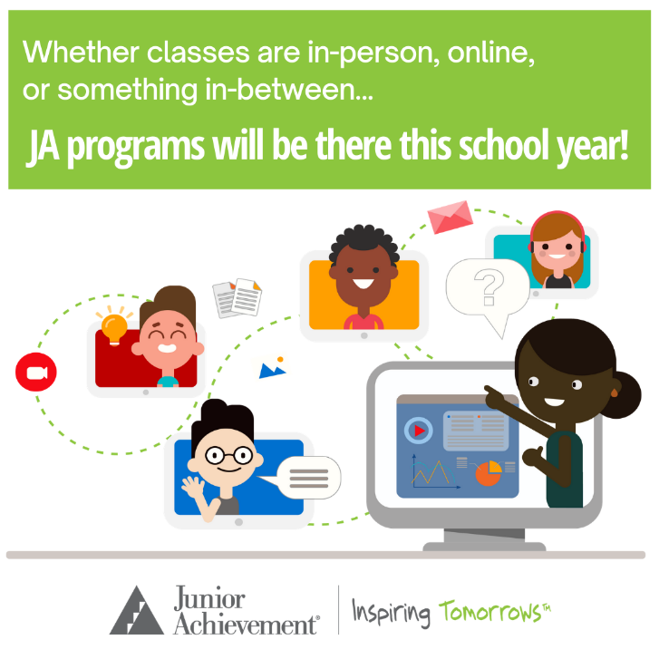
What is it?
This event showcases business professionals from a wide variety of careers who share their education background and all about their careers! This year, the experience will be available to students fully online!

How does it work?
Volunteers can create a 5 to 7-minute video using Flipgrid (an easy website that you push a button to record and then take a quick selfie at the end and everything will upload to JA). And if you speak Spanish, we would love if you can create a similar video in Spanish as the one you create in English.

Is there a time commitment?
Everything will be pre-recorded and accessible to students on a flexible schedule. There is no time
commitment outside of submitting your information and video! Please submit by December 31, 2020.

Sample Topics to Cover in Your Video:
- Introduce yourself and your company/organization.
- Share your “job story” with the students—what you do to earn a living (basic job description).
- What does your typical day-to-day work look like?
- What do you love about your work?
- What did you want to be when you were in elementary, middle or high school?
- How many different types of jobs have you had?
- What is the first job you had out of college or after training and how did you get hired?
- Explain what your education path looked like.
- Did your education guide you to the career you’re currently in or did things shift along the way?
- What education, training, or certifications have you acquired?
- What advice would you give to your younger self, if you choose your career path over again?
- Are there resources or any additional information you think it’s important for students?

TO PARTICIPATE, COMPLETE THESE 3 EASY STEPS:

STEP 1: COMPLETE THE SURVEY
This survey lets JA know you are willing to participate in the virtual fair and provides essential information for your booth. Click here to complete!

STEP 2: CREATE YOUR VIDEO*
Tell us about yourself and your profession. You may record alone or with colleague(s). Submit 1-3 videos/group. Click here to make your video!

STEP 3: COMPLETE YOUR JA REGISTRATION:
Add your info to the JA platform so we can share your videos and track participation here.

Amy Youngberg | Senior Director of Operations
Junior Achievement of Chicago
630.577.7628 | ayoungberg@jachicago.org

*To record, you need either a Microsoft or Google account. Use your laptop or download the free Flipgrid app to your phone. After recording, press the arrow to review, take a picture, and submit. Contact Amy Youngberg at ayoungberg@jachicago.org, if you have any trouble or need an alternate format!

